**Hungry Cat**

1. Add an Apple sprite to the stage.

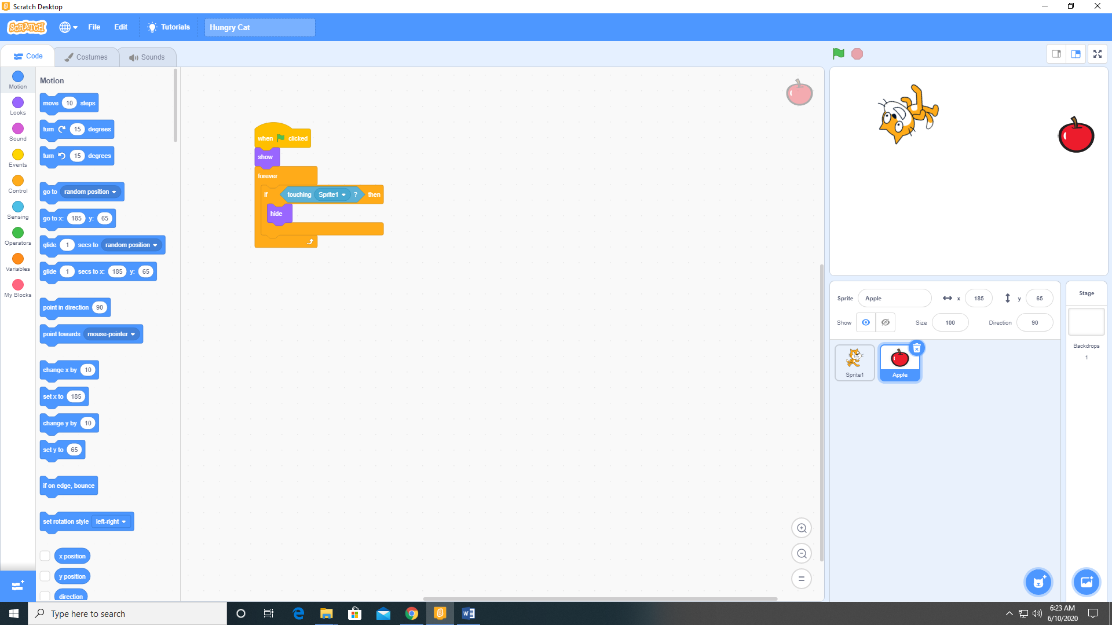

1. Add the following code to Sprite1 (the cat)

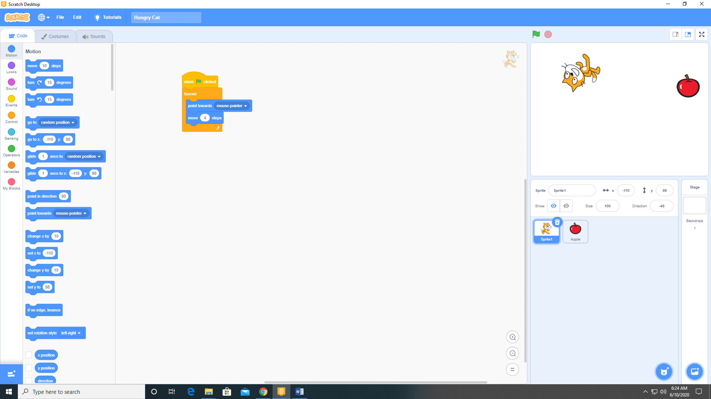

1. Add the following code to the Apple sprite.

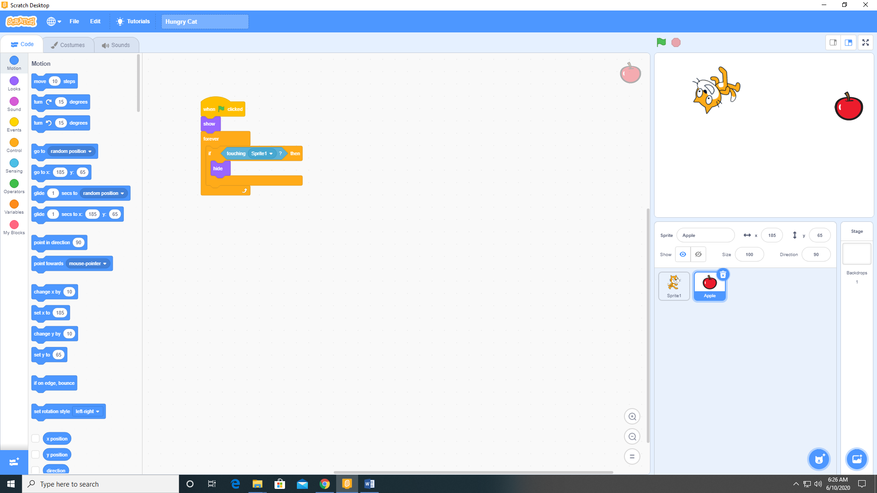

1. Duplicate the Apple sprite several time and arrange on the stage.

